Normalization

use http://www.guru99.com/database-normalization.html

The theory of Normalization
- process
  - Identifying potential problems, called updating anomalies, in the design of a relational database
  - Methods for correcting these problems
- Normal form: table has desirable properties
  - First normal form (1NF)
  - Second normal form (2NF)
  - Third normal form (3NF)
  - Fourth normal form (4NF)
- Normalization Rule of Thumb
  - Table in first normal form better than table not in first normal form
  - Table in second normal form better than table in first normal form, and so on
  - Goal: new collection of tables that is free of update anomalies

Why do we normalize?
- free of update anomalies (problems)
  - if I update (change, delete or edit), I shouldn’t have to throughout the table
- tables are smaller
- save space
  - there may be more records! But less overall data since repeated less

Functional Dependence
- Column B is functionally dependent on column A
  - Each value for A is associated with exactly one value of B
- A functionally determines B
  - Column B is functionally dependent on another column A (or collection of columns) when each value for A in the database is associated with exactly one value of B
- The only way to determine the functional dependenices that exist is to examine the user’s polices

StudentNum | StudentL | StudentF | HighSchoolNum | HighSchoolName | Adnum | AdL | AdF
- Identify columns that will be unigiue (as in only one person could have a #)
- for those columns identified, determine what other columns

Keys
- Column A (or a collection of columns) is the primary key for a relation R
  - Property 1: all columns in R are functionally dependent on A
  - Property 2: no subcollection of columns in A also have Property 1
- Candidate key: column(s) on which all columns in table are functionally dependent
- Alternate keys: candidate keys not chosen as primary key
- Column(s) A is the primary key if all other columns are functionally dependent on A and no subcollection of columns in A also have this property

First Normal Form
- A Table in first normal form (1NF) does not contain repeating groups
  - Repeating group: multiple entries (data) for a single record
  - Unnormalized relation: contains a repeating group
  - Some may already come in 1NF!!

1NF Example
Unnormalized | Normalized
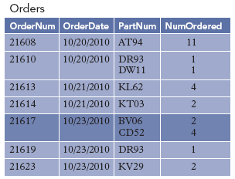  Orders(OrderNum, OrderDate, PartNum, NumOrdered) | 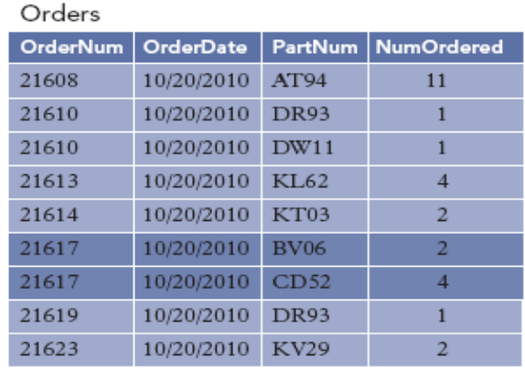  (dates are all wrong - typo)

Second Normal Form
- Table (relation) in second normal form (2NF) when
  - Table is in first normal form (1NF)
  - No nonkey column is dependent on only a portion of primary key
    - Nonkey column (nonkey attribute): not part of primary key
- Worries about redundant data, that COULD have update anomalies or inconsistent data
  - when rows are Updated, Additions, Deleted
    - an ID# will never be changed, even if the person/part does
  - Inconsistent data, could you change one, and the rest would not update?
- You will have to create more tables (but smaller in size and data)
- You may have to ADD columns (like an ID)

Non-2NF Table and possible problems
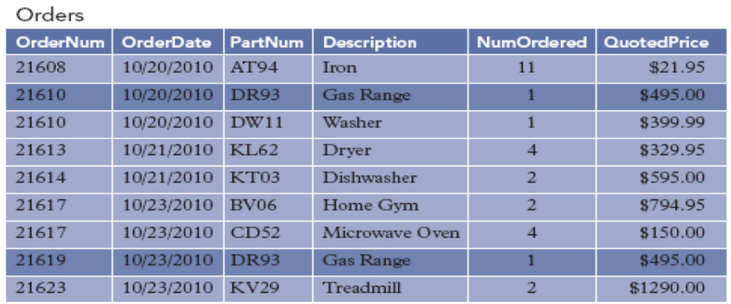
- Notice that if I made ONE change in a record, I would have to find OTHERS to change as well!!
  - Example, what if I needed to change the Gas Range’s part number to something new. It’d have to go through ALL of the records and change them!!
  - No no!!
  - So let’s break it down so if I make a change, it will be made DB wide.

- Converting to 2NF
  - Table must FIRST be in 1NF
  - Dependency Diagrams in Normalization
    - arrows indicate all functional dependencies
    - Arrows above boxes: normal dependencies
    - Arrows below boxes: partial dependencies
    - dependencies are formed by logic

Dependency diagrams for Orders Table
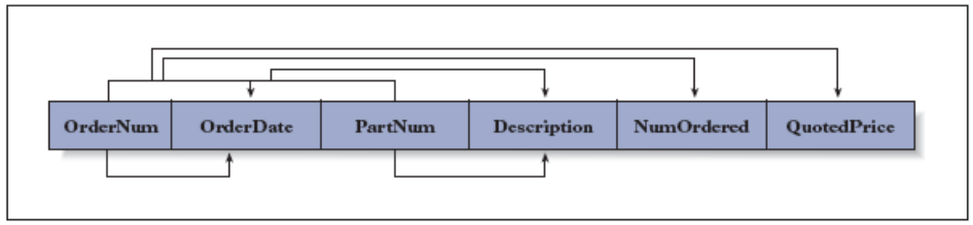

Finalized 2NF for OrderLine to these tables
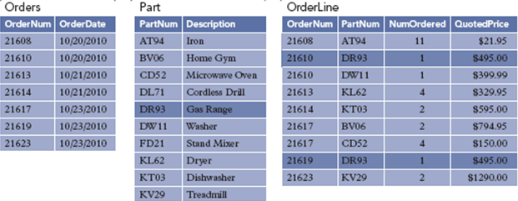
Orders(OrderNum, OrderDate)
Part (PartNum, Description)
OrderLine(OrderNum, PartNum, NumOrdered, QuotedPrice)

Third Normal Form (3NF)
- 2NF tables may still contain problems
- tables may have wasted space and Redundancy
- could also have the same update anomalies and redundancy as before!!
- so we look for Determinants:
  - column(s) that determines another column
  - Its only determinants are candidate keys

Customer Table Example
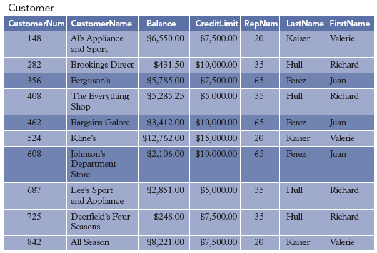

Customer Table Dependencies
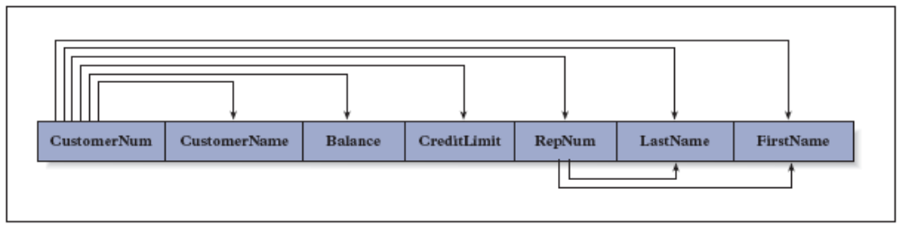

Correction procedure
- For each determinant that is not a candidate key, remove from table the columns that depend on this determinant
- Create new table containing all columns from the original table that depend on this determinant
- Make determinant the primary key of new table
Customer Table Normalized to 3NF
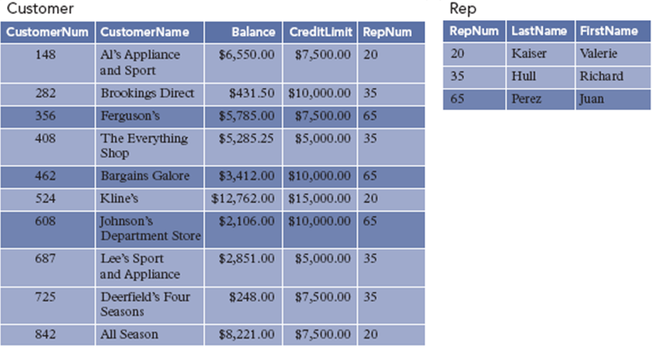
Customer(CustomerNum, CustomerName, Balance, CreditLimit, RepNum)
Rep(RepNum, LastName, FirstName)

Fourth Normal Form (4NF)
- It is in third normal form
- No multivalued dependencies
- Converting table to fourth normal form
- Split third normal form table into separate tables, each containing the column that multidetermines the others
- Avoiding the Problem with Multivalued Dependencies
  - Place each repeating group in separate table
  - Each table will contain all columns of a repeating group, and primary key of the original table
  - Primary key to each new table will be the concatenation of the primary keys of the original table and the repeating group

Conversion to 4NF
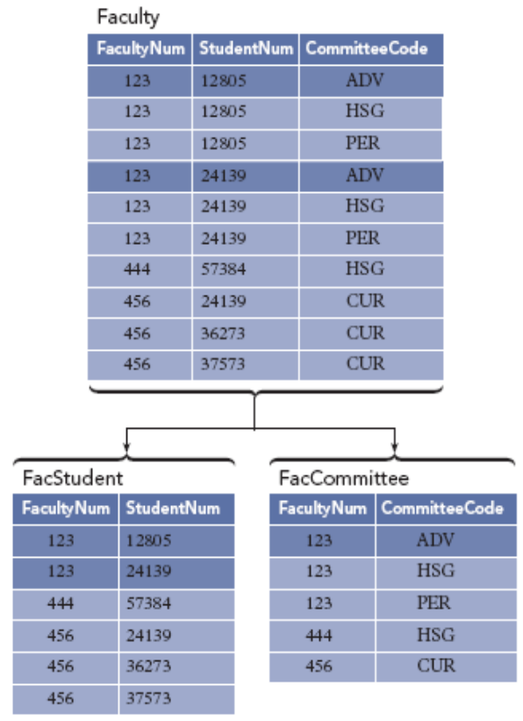

Overall Idea
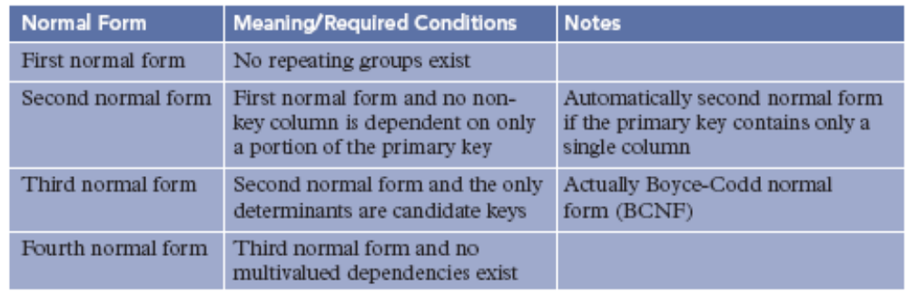

From start to Finish Example
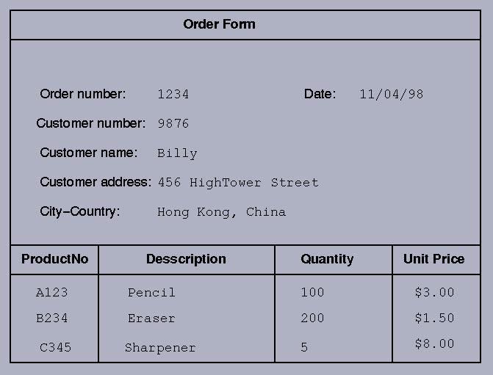

Produce the Third Normal Form of this document by normalization.
- 0NF
  - ORDER(order#, customer#, name, address, order_line(product#, description, quantity, unitprice))
- 1NF
  - ORDER(order#, customer#, name, address, orderdate)
  - ORDER_LINE(order#, product#, description, quantity, unitprice)
- 2NF
  - ORDER(order#, customer#, name, address, orderdate)
  - ORDER_LINE(order#, product#, quantity)
  - PRODUCT(product#, description, unitprice)
- 3NF
  - ORDER(order#, customer#, orderdate)
  - CUSTOMER(customer#, name, address)
  - ORDER_LINE(order#, product#, quantity)
  - PRODUCT(product#, description, unitprice)
Draw this out.

